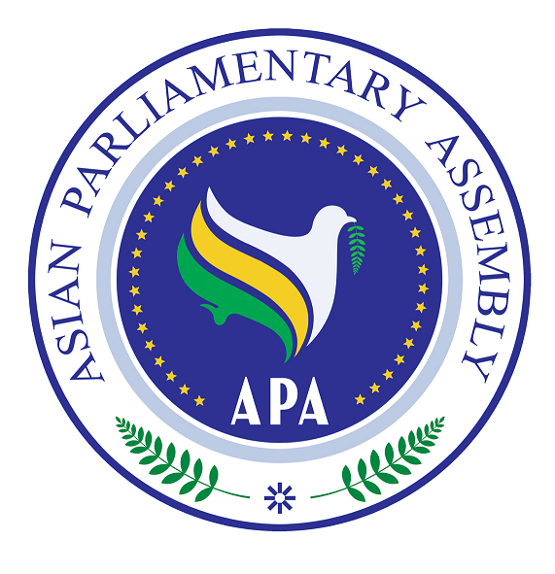
Asian Parliamentary Assembly (APA)

REGISTRATION FORM
APA Coordinating Meeting on the sideline of the 143nd IPU Assembly
(Friday 26 November 2021- 16:00- 17:30)
Assembly Venue- Roma Hall
SPAIN- MADRID

Please fill in one registration form for each participant (in block capitals) and return it to APA Secretariat at the following e-mail address latest by 20 November.
- Delegation of: …………

- Title: Please check Mr. Ms. Dr. other
- First Name:
- Last Name:

- Position in the parliament
……………………………………………………………………………………

- Phone No. | - …………………..……………………………………………..  - Country Code City Code Number
- Cell phone  - Fax No. | - …………………………………………………………………  - ………………………………………………………………..
- Email Address: | - ……………….……………………………………………..

Any Proposal on Emergency Item:

